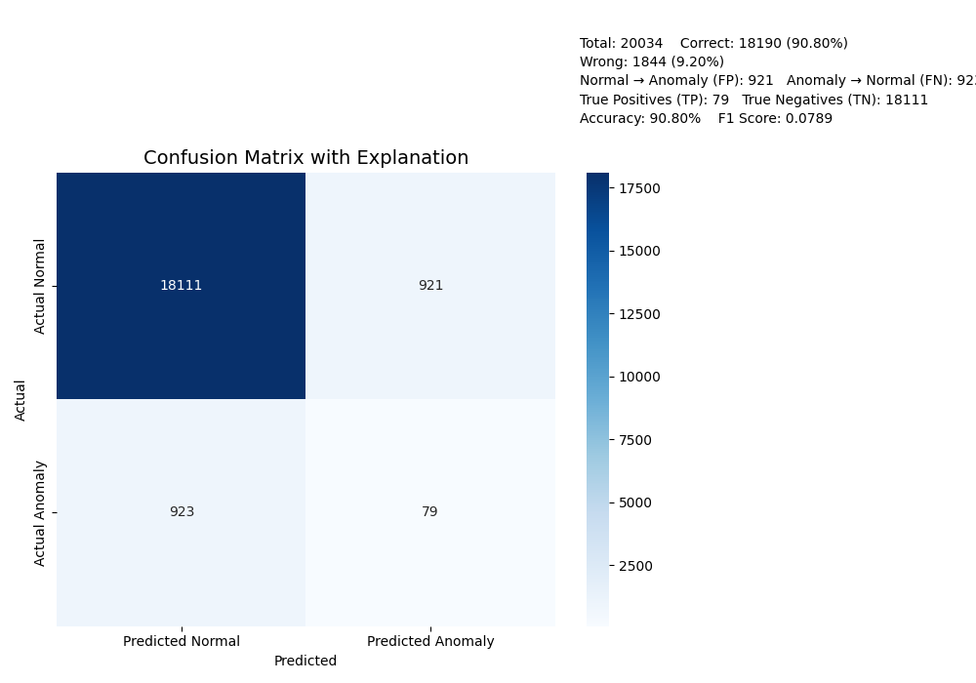

**We Take a Unsupervised Network Traffic Log Data : sample.csv**

**Source : https://www.cecresearch.com/**

**Make it leveled using isolation forest Algorithm , like which traffic is ‘normal ’ or ‘anomaly’ : classified_traffic_full.csv**

**About : isolation forest Algorithm**

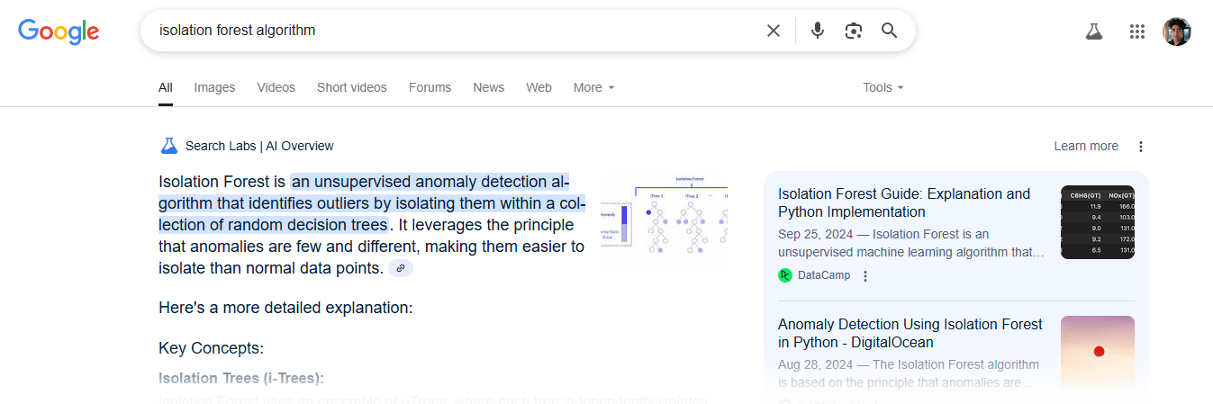

**Now with this leveled data , we train a model using Random forest classifier : rf_anomaly_model.pkl**

**about**

**https://www.geeksforgeeks.org/random-forest-algorithm-in-machine-learning/**  
 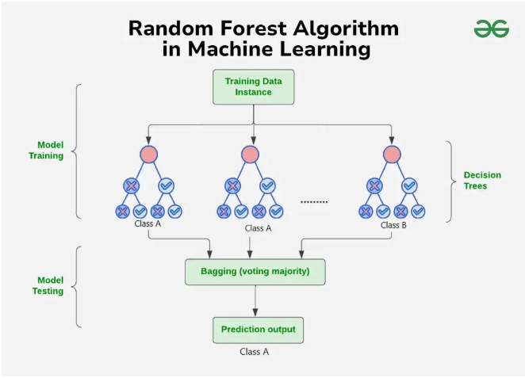

**After that we tell model to create a prediction on unsupervised data for ‘anomaly’**

**Now it create a leveled data with prediction : test_output.csv**

**Then we match the supervised data , with machine leveled data**

**And calculate the error rate and False positive and False Negative**